It’s Always 1849 in the Stock Market

John Sutter left his homeland of Switzerland and arrived in New York City in 1834. It was the age of Manifest Destiny, when enterprising young men such as John headed to the Western U.S. to seek a new and exciting life and try to tame the frontier. John traveled through St. Louis, Santa Fe, Oregon, Hawaii, and Alaska, before finally settling in a new but beautiful seaport known as Yerba Buena by 1839.

After those five years of gallivanting around, Sutter was ready to settle down a bit. He took some land along a river not far from Yerba Buena, built a saw mill, and tried to live a relatively peaceful life.

Gold Rush

Then in 1848, one of his foremen found some shiny metallic flakes in the water near his mill, and the rest of Sutter’s life was anything but peaceful. By the end of that year word had spread far and wide that gold had been discovered. At the end of 1848, the population of San Francisco (which had been renamed from Yerba Buena a year earlier) was about 1,000; by 1850 it was at least 25,000.

What happened in the intervening year of 1849 is now part of our historical lore, but it is something that happens over and over and over again in the stock market. Not many people pay attention to a given company or sector, then all at once it becomes THE place to be, and thousands of investors are suddenly falling over each other trying to buy into it, driving the prices up to unsustainably high levels.

Rail Rush

For instance, just a quarter century before the Gold Rush, a new and exciting industry was in its infancy. Rail travel was beginning, though it did have some initial concerns to overcome: the Quarterly Review wrote in 1825, “What could be more palpably absurd than the prospect of locomotives traveling twice as fast as stagecoaches?” Nonetheless, railroads really took hold of investors’ fascination.

From its starting point in 1825, rail made up about zero percent of the U.S. transportation landscape, as measured by ton miles. By the end of that century, the industry was firmly entrenched, and publicly-held rail-related companies made up an astounding 63% of the total market cap of U.S. stocks. Since then, many technological innovations have diminished the value railroads to our economy, and today rail companies make up less than 1% of the value of the U.S. stock market.

Canal Rush

Before railroads came along, the hot new industry of the day was canals. Transportation by canal was sixty times more efficient than using horses and wagons, and investors simply ate it up. Canal stocks rose, on average, about 140% in the early part of the 19th century. With the advent of railroads, though, canals’ efficiency suddenly started to look rather inefficient, and canal company stocks declined 70% from 1825 through 1850. And in case you don’t have a calculator handy, we’ll do the math for you: a 140% rise followed by a 70% decline works out to an overall loss of 28%.

Automobile and Airplane Rush

There are currently three major publicly-traded U.S. automobile manufacturers: Ford, General Motors, and Chrysler (now owned by Fiat), and this has been the situation for at least the last 40 years. But do you have any idea how many there were before that? At least 2,000 makes have existed at one time or another. Do the names Stanley Steamer, Hudson, or Nash ring any bells? But if an investor looked at the way canals and railroads changed the landscape of America and recognized the potential of the automobile, he might have concluded that buying car stocks was a sure thing. Unless he had picked one of the eventual three winners, he would surely have been wiped out due to all the competition.

A similar situation exists in the sky. Today we have a handful of major carriers, including American Airlines, Delta, United, and Southwest. But due to similarly fierce competition, the cumulative profits earned by all U.S. airlines from the dawn of the industry until the end of the 20th century was actually negative.

Technology Rush

In 1999, technology-related companies made up 29% of the overall value of the S&P 500 index. After initially contracting to 14%, that figure has recovered somewhat and currently stands at 21%. But as the chart below shows, in 1992 that number was just 5%! For that figure to go from 5% in 1992 to 29% just seven years later took a lot of doing…. many Initial Public Offerings (IPOs), lots of venture capital, lots of new sector-specific mutual funds, and so on. For any investors who hopped on board the Technology Express late in the game, say 1998 or 1999, they were left holding the bag at the bottom of the market in 2002.

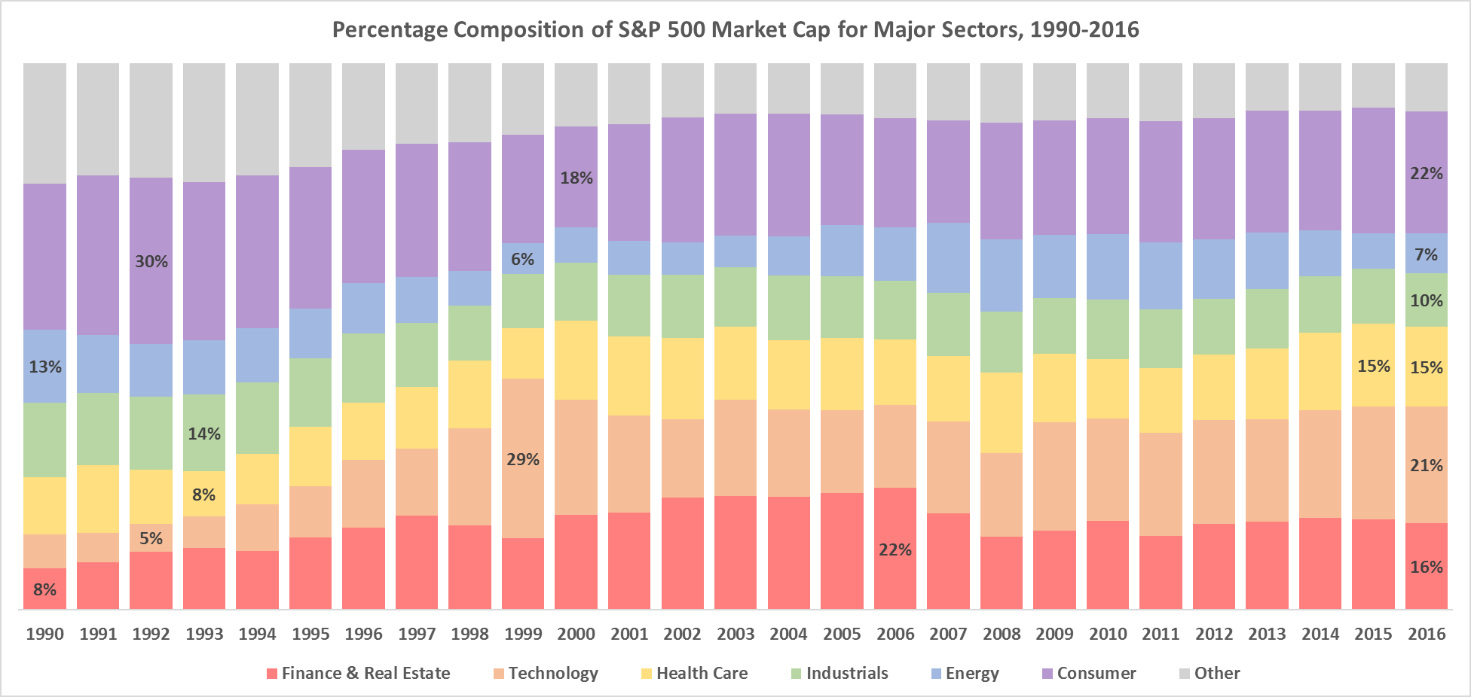

While some of the booms and busts from above took multiple decades to fully play out, sometimes the stock market moves much faster than that. Look again at the chart above and see how the composition of the S&P 500 has changed over the last 25 years. Financials at one point accounted for as little as 8% of the overall market cap, then grew to be the largest sector of the bunch, accounting for a full 22%, until settling in to their current level of 16%. In other words, financials now account for double what they once did, down from triple.

And though not as dramatic, the Energy sector has seen its allure wax and wane. From a peak level of 13% of the overall market in 1990, that percentage declined to just 6% by 1999, only to rise again to 13% by 2008, and then fall again to 7% today.

Perhaps Horace had the stock market in mind when he prophesied around the year 40 B.C.: “Many shall be restored that are now fallen, and many shall fall that are now in honor.”

Don’t Rush!

So what’s the lesson here for investors? It is extremely difficult to make money in young industries. Many academic studies have shown that most IPOs turn out to be rather poor investments, so it’s best to just sit them out. Sure, with the benefit of hindsight, some IPOs like Google or Facebook seem like they must have been no-brainers at the time, but don’t forget about the dozens of others like Pets.com or DrKoop.com. For that matter, don’t forget about Stanley Steamer or Nash or Braniff or Pan Am or the New York Central or Reading Railroads. Or even John Sutter himself, who died in relative obscurity—and certainly not any meaningful wealth—in 1880 and was buried in a modest cemetery in the Pennsylvania countryside.

Felipe Garcia, CFA Aaron Byrd, CFA
Chief Investment Officer President
Inkwell Capital LLC Inkwell Capital LLC

